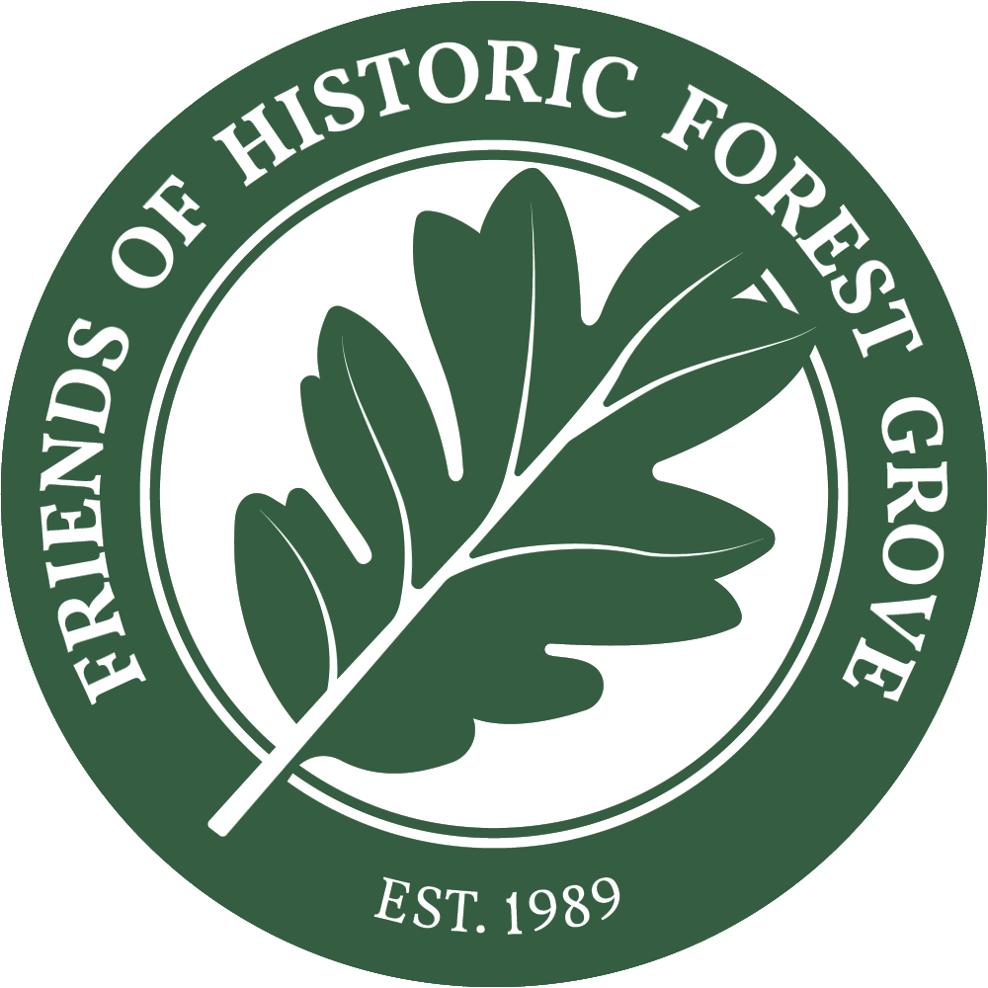
FRIENDS OF HISTORIC FOREST GROVE
SCHOLARSHIP APPLICATION

Qualifications: Applicant must be a Forest Grove High School graduating senior outstanding in history, with plans to attend community college or university for a degree in history, historic preservation, social studies, government, anthropology, archaeology, teaching history or social studies, or closely-related field.

Scholarship award: $1000
Please include: this completed application, two letters of recommendation (one from your history teacher and another from a community member), FGHS transcript, additional attachment with your name/date on it for short response questions and essay described below.

Deadline: Please submit completed applications to Ms. VanLoo by 4 pm, February 28.

Name: _______________________________________________________________________________
Phone: _______________________________________________________________________________
Email: __________________________________________________________ GPA: _________________
Home Address: ________________________________________________________________________
Name of Parent(s) or Legal Guardian: ______________________________________________________
Have you applied for financial aid (FAFSA)? ____Yes ____No
From the FAFSA, what is your expected family contribution (EFC)?_____________________

Where do you plan to attend school after high school? Have you received official acceptance?

1st choice: ________________________________________ ________________________
2nd choice: ________________________________________ ________________________
3rd choice: ________________________________________ ________________________

Please attach a maximum 350 word essay describing your roots in Forest Grove and/or how Forest Grove history is relevant to you.

I understand that any scholarship I receive will be used for college-related expenses and that the information provided here is true to the best of my knowledge.

Applicant’s Signature _______________________________________________ Date __________________
Briefly answer the following questions:

What are your college and career plans?
______________________________________________________________________________________

______________________________________________________________________________________

______________________________________________________________________________________

______________________________________________________________________________________

______________________________________________________________________________________

______________________________________________________________________________________

______________________________________________________________________________________

How have you demonstrated interest in history, heritage or historic preservation? (list relevant coursework, projects, volunteering)

______________________________________________________________________________________

______________________________________________________________________________________

______________________________________________________________________________________

______________________________________________________________________________________

______________________________________________________________________________________

______________________________________________________________________________________

Have you ever participated in an activity with Friends of Historic Forest Grove? ___Yes ___ No
(If yes, please describe.)
______________________________________________________________________________________

______________________________________________________________________________________

______________________________________________________________________________________

______________________________________________________________________________________

______________________________________________________________________________________

